Project report on XML and DATABASE, course 7.5 points with in Computer Engineering

**Title**

Flight booking Website

**Givenname Surname**

Shixian Wen

Abstract

This Project mainly focus on using the combination of XML technologies and a My SQL relational database and the HTML(PHP) web page design. XML is composed of markup language for structuring data and has become a standard way to describe data on the Web.

Flightbooking is a flight booking website which uses these technologies to provide a platform for people searching suitable flights, booking tickets and revoking tickets. Also, you can enjoy the latest CNN news on our websites by using RSS technology.

This website can get user’s input data from the client-side, using 3 methods to validating it HTML form, JavaScript and XML Schema Definition(XSD). Then the application will store these data in the XML files and Database. Third, data stored in the MY SQL database are retrieved, transformed and presented using XSLT, XPATH, XQUERY and CSS.

Keywords: XML, XSLT, XPATH, MYSQL, XQUERY, XSD, HTML, PHP, RSS,CSS, Flightbooking

content

1 Introduction 4

2 Theory 5

3 Method and code implementation 9

4 Results and Discussion 15

5 Conclusions 18

# 1 Introduction

* 1. Background

Everybody has need to book the tickets for travel and get the information of what’s happened around us. In this application, XML technologies tools such as XML, XSLT, XPATH, MYSQL, XQUERY, XSD,RSS are used to describe, transform, present and transport data. The database system helps us to store data more persistent and well-structured. Flightbooking Website has explored XML technologies ,MySQL database technologies, HTML,PHP techonologies fully in fulfilling its function.

* 1. Overall aim

The overall aim of this project is to demonstrate a practical use of XML technology and a relational database in order to achieve the designing goal: a website that can be used to search book, revoke flights and leave comments to the airline company.

# 2 Theory

2.1 XML

Quoted from Wikipedia “ Extensible Markup Language (XML) is a markup language that defines a set of rules for encoding documents in a format which is both human-readable and machine-readable. It is defined by the W3C's XML 1.0 Specification[2] and by several other related specifications,[3] all of which are free open standards.[4]

The design goals of XML emphasize simplicity, generality and usability across the Internet.[5] It is a textual data format with strong support via Unicode for different human languages. Although the design of XML focuses on documents, it is widely used for the representation of arbitrary data structures[6] such as those used in web services.

Several schema systems exist to aid in the definition of XML-based languages, while many application programming interfaces (APIs) have been developed to aid the processing of XML data.”

2.2 XSD

Quoted from Wikipedia ”XSD (XML Schema Definition), a recommendation of the World Wide Web Consortium (W3C), specifies how to formally describe the elements in an Extensible Markup Language (XML) document. It can be used by programmers to verify each piece of item content in a document. They can check if it adheres to the description of the element it is placed in.[1]

Like all XML schema languages, XSD can be used to express a set of rules to which an XML document must conform in order to be considered "valid" according to that schema. However, unlike most other schema languages, XSD was also designed with the intent that determination of a document's validity would produce a collection of information adhering to specific data types. Such a post-validation infoset can be useful in the development of XML document processing software.”

2.3 XPATH

Quoted from Wikipedia” XPath, the XML Path Language, is a query language for selecting nodes from an XML document. In addition, XPath may be used to compute values (e.g., strings, numbers, or Boolean values) from the content of an XML document. XPath was defined by the World Wide Web Consortium (W3C)”

2.4 XSL

Quoted from Wikipedia” XSLT (Extensible Stylesheet Language Transformations) is a language for transforming XML documents into other XML documents or other formats such as HTML for web pages, plain text or into XSL Formatting Objects, which may subsequently be converted to other formats, such as PDF PostScript and PNG.”

2.5 Database

Quoted from Wikipedia” Formally, a "database" refers to a set of related data and the way it is structured or organized. Access to this data is usually provided by a "database management system" (DBMS) consisting of an integrated set of computer software that allows users to interact with one or more databases and provides access to all of the data contained in the database (although restrictions may exist that limit access to particular data). The DBMS provides various functions that allow entry, storage and retrieval of large quantities of information as well as provide ways to manage how that information is organized.”

2.6 PHP

Quoted from Wikipedia” PHP is a server-side scripting language designed for web development but also used as a general-purpose programming language.”

2.7 XML DOM

Quoted from W3school” The XML DOM is

:A standard object model for XML

A standard programming interface for XML

Platform- and language-independent

A W3C standard

The XML DOM defines the objects and properties of all XML elements, and the methods (interface) to access them.

In other words: The XML DOM is a standard for how to get, change, add, or delete XML elements.”

2.8 HTML

Quoted from Wikipedia” HyperText Markup Language, commonly referred to as HTML, is the standard markup language used to create web pages.[1] It is written in the form of HTML elements consisting of tags enclosed in angle brackets (like <html>). HTML tags most commonly come in pairs like <h1> and </h1>, although some tags represent empty elements and so are unpaired, for example <img>. The first tag in a pair is the start tag, and the second tag is the end tag (they are also called opening tags and closing tags).

Web browsers can read HTML files and compose them into visible or audible web pages. Browsers do not display the HTML tags and scripts, but use them to interpret the content of the page. HTML describes the structure of a website semantically along with cues for presentation, making it a markup language, rather than a programming language.”

# 3 Method and code implementation

**3.1 overall system design**

From figure 1, you can see that our web application are consist of three tier that include: Client Tier, Logic Tier(Application Server) and Database Tier. Client Tier plays a role of interface between our clients and application server. This Tier collects user’s input using HTML forms and using post method to send it to the Application Sever. Logic Tier plays a role of manipulating users input, processing it using PHP, JavaScript and XML technologies. Then, it creates a connection to MYSQL database for data storage and sends a response to the user such as telling them your tickets have been booked successfully. The Database saves the data that have been processed in the Application Server and also provides methods to retrieving and manipulating the data, ensuring the data persistence across the whole system.

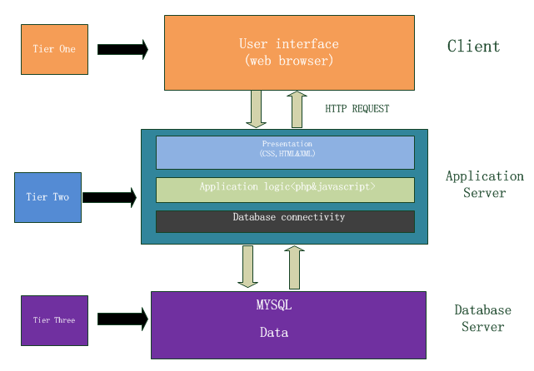

Figure 1 **overall system design**

**3.2 Data flow chart:**

In order to achieve data security and data integrity, we use the following data flow chart shown in figure 2. When user type their tickets information in the HTML form, our system collects and converts the input data into an XML file. By using XSD and javaScript to validate the input data, we can tell if these input data are correct or not. If the result is incorrect, we will return alert window to the user, reminding them to type it again. If the result is correct, we save these data in the database and local xml files.

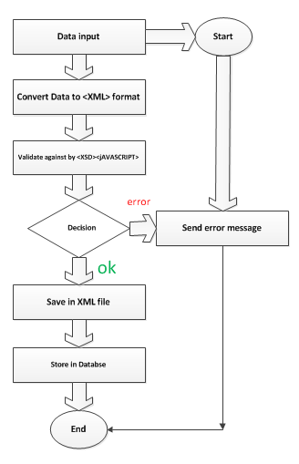

**figure 2 data flow diagram**

**3.3 Data Restriction Model**

In this section, we will look the Data Restriction Model in details. As shown in Data flow chart, we use Both JavaScript and XSD to ensure that all the data that going to our system are in well format and correct. Figure 3 and Figure 4 show the result of the combination of JavaScript and XSD to ensure our system safety. Figure 5 gives us a sample of how we write XSD. If you want to look the code implementation in details, please refer to books.xsd and validate.min.js in the file.

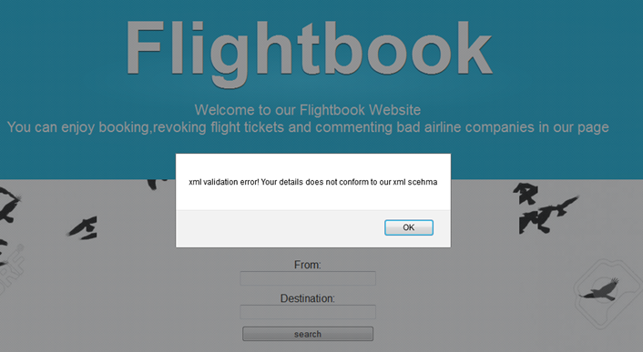

Figure 3 XSD validation error

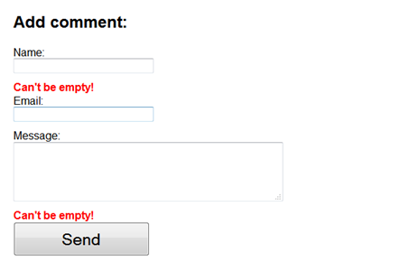

Figure4 JavaScript validation

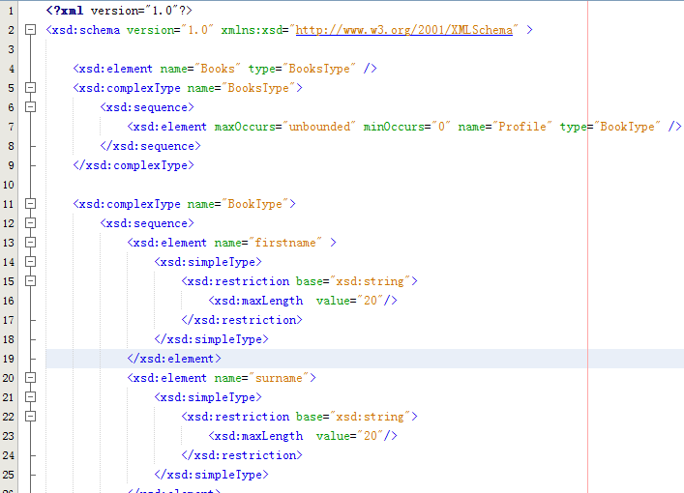

Figure 5 books.xsd

**3.4 User Data Structure**

In this Section, we will discuss the user Data Structure. When a user successfully searched the flight they want in our website, they can fill the “book your tickets form” in our webpage which will successfully generate the XML data storing the user’s personal information and put them into database. We use their username as a key. If users want to revoke their tickets latter, they can fill another form to revoke the tickets they have booked. Our website will check the username and password, comparing them with the one that we store in our database to verify the validity. If they are not satisfying the service of the airline company, they can leave some comments in our website. In figure 6, figure 7 and figure 8, you can see our data structure of flight information, booking information and comments information separately.

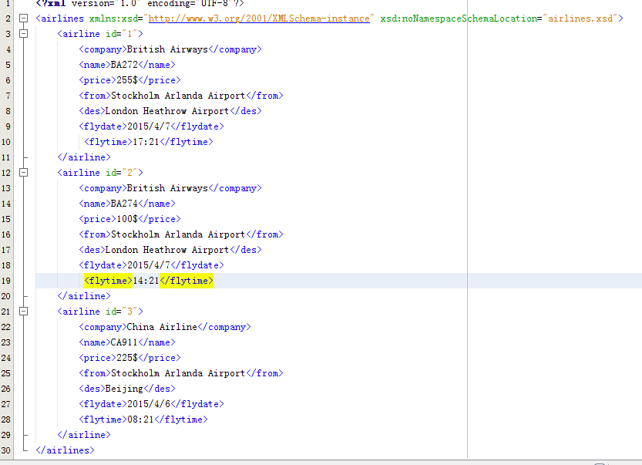

figure 6 data structure of flights

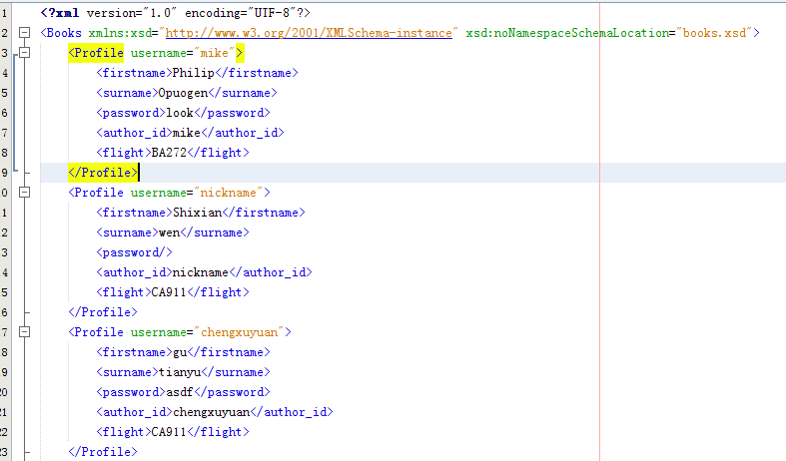

Figure 7 data structure of books

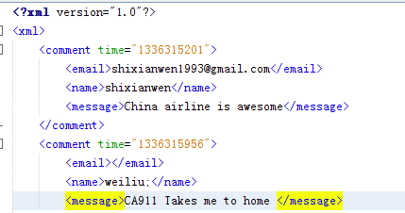

Figure 9 data structure of comments

**3.5 User Data Processing**

When our application get the data from the users, we process the data via XPATH, XSD, PHP and SQUERY technologies.

For example when users successfully submit their booking data in our webpage, we use book.php to process the user data. First we use XPATH to see whether their username has already stored in our xml files, if they have already been registered, we return an alert for the users to change a username. If it is not, we will check if the data is validated or not by using XSD. If is being validated, we will update the XML files and database by using DOMXML and SQUERY. In figure 10 there are sample program of how we process the data.

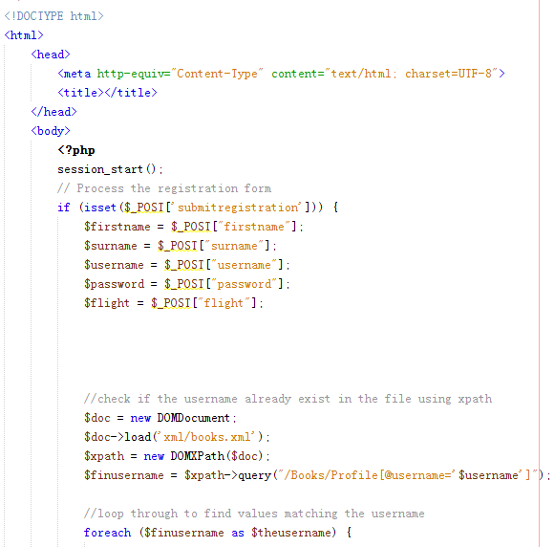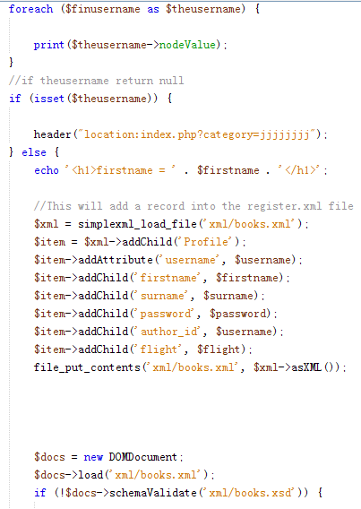

# C:\d\学习\大四\xml\report\新建文件夹\3.pngC:\d\学习\大四\xml\report\新建文件夹\4.pngfigure 10 process the books information and insert data into xml and database

# When User want to revokes their tickets, they can use revoke form shown in our websites which is processed by revoke.php. In revoke.php, we retrieve password and username from the database, comparing them with the user’s typing. If the result is matched, we delete the booking data in the xml and database via Squery and PHP. The sample program shown in figure 11C:\d\学习\大四\xml\report\新建文件夹\5.pngfigure 11 match and delete data in database

**3.6 XML Transformation**

We use XSLT technology to display all the comments. The XSL document(comments.xsl) specifies how the XML(comments.xml) document should be displayed. The description of XSL document is a static HTML. XSL treat the XML as a tree to access and search the data. Figure 11 shows the comments.xsl.

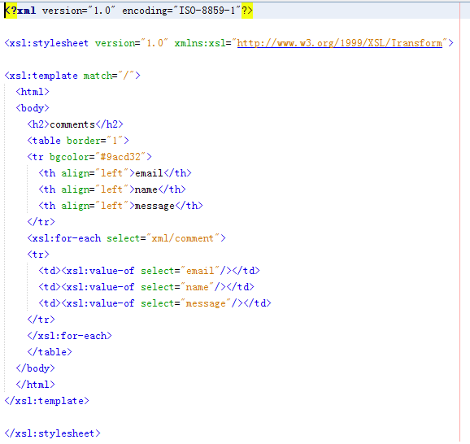

Figure 11 XSLT(comments.xsl) file

**3.7 Load remote XML by using RSS**

In our webpage, by getting feeds from the RSS document which stores in XML format, the latest news of CNN is updated automatically and represented in our homepage. You can pick one which you want to read. The code implementation are shown in Figure 12

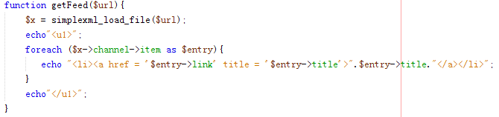

Figure 12 automatically upload latest news by using rss providing by CNN

# 4 Results and Discussion

1:Bit Error rate

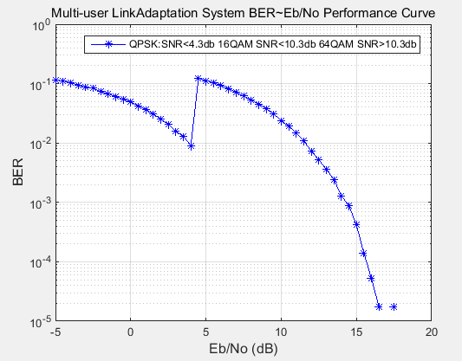

Figure 4.1 Bit Error Rate

In our presentation, we made a mistake that we mistakenly took the BLER as the BER(see Figure4.2 [4]).

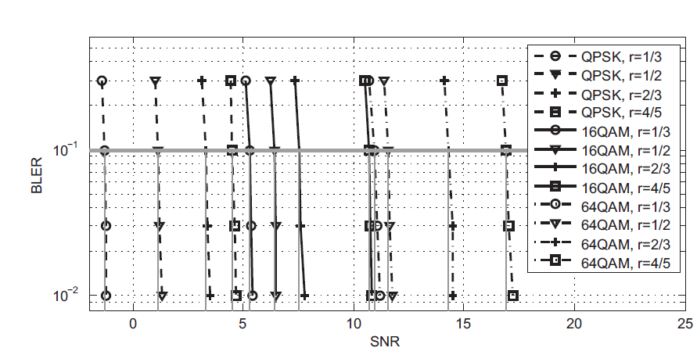

Figure 4.2 Block Error Rate

3GPP TS 34.121, F.6.1.1 defines block error ratio (BLER) as follows: "A Block Error Ratio is defined as the ratio of the number of erroneous blocks received to the total number of blocks sent. An erroneous block is defined as a Transport Block, the cyclic redundancy check (CRC) of which is wrong.

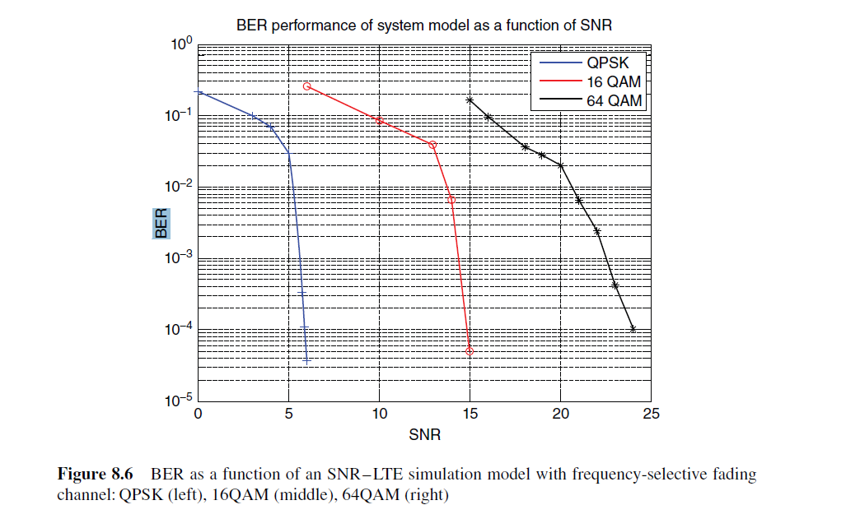

Figure 4.3 BER performance of system model as a function of SNR[I cannot find the resource again]

There is a great leap between 16 QAM and 64QAM in the reference we found. We think this is because in this simulation, we set all of the channel idex to 1 which is a perfect channel situation which might affect the final results.

2:The Data Rate we achieved by assigning each users 125 subcarriers

We can check the parameter user_bit in matlab to get the bit rate of one user in one subframe. After some simple calculation, we get

2.88MB/USER*S QPSK 4 user 8MB/S

5.76MB/USER*S 16QAM 4 user 23.04MB/S

8.64MB/UESR*S 64QAM 4 user 34.56MB/S

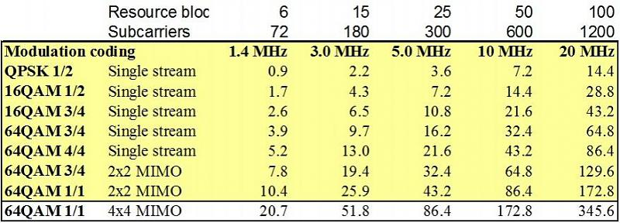

Figure 4.4 Bandwidth with different modulation coding[4]

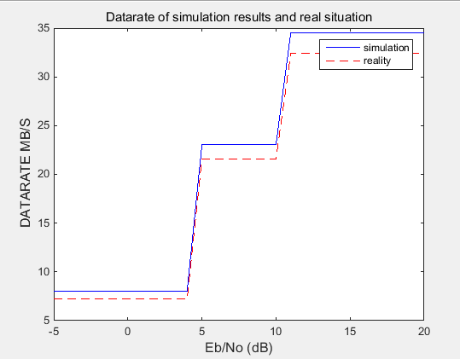

Figure 4.5 Bandwidth with different modulation coding

The results we get is compatible with the 10MHZ bandwidth condition. However, our data rate is higher. The difference is because we do not implement the SSS and PSS and User Specfic reference signals etc. In a another word our simulation result is gross bitrate which contains the total number of physically transferred bits per second over a communication link, including useful data as well as protocol overhead. The reality is the net bitrate. So our simulation results is higher than the real condition.

# 5 Conclusions

Our project is just a simplification of the LTE system. From the simulation results, our system satisfies the specification of the real LTE system by comparing the BER and Data Rate.

Here are some further work we need to do:

1: implement the channel coding which is shown in Figure 5.1[3]

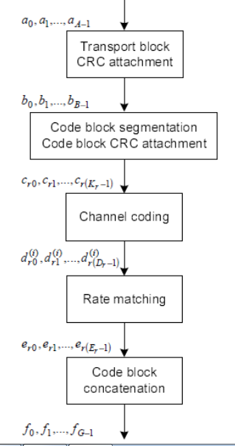

Figure 5.1 Channel coding procedure

2: implement 3 feedbacks: CQI,RI,PMI cite from:[4]

Link adaptation: The techniques that dynamically change system parameters based on channel conditions.

To enable dynamic changes to MSCs and for proper operation of MIMO schemes, the LTE standard provides mechanisms that enable information regarding the channel characteristics to be measured by the mobile unit. This information is then fed back to the base station to help with scheduling and link adaptation.

At the receiver, 3 types of channel-state report are generated and transmitted to the base station.

1) The CQI, a measure of downlink radio channel quality that specifies the best modulation constellation and coding rate to match the link quality.

2) The PMI, a measure that indicates the best set of precoding matrices for use in closed-loop single- and multi-user spatial multiplexing modes of the LTE standard.

3) The RI, which signals the number of useful transmission layers that can be used by the transmitter in spatial multiplexing modes.

1. References
2. Stefania Sesia, Issam Toufik, Matthew Baker-LTE-The UMTS Long Term Evolution_From Theory to Practice-Wiley. 2011.
3. Dahlman E.,et al.-4G LTE_LTE-advanced for mobile broadband-Elsevier. 2014

[3]3GPP. <http://www.3gpp.org/>

[4]Zarrinkoub H.-Understanding LTE with MATLAB-Wiley. 2014.